Climate Resilience Brief Report
Generated 24 October 2026 · RRAS — LGED Road Resilience Assessment System
Amtali (AK High School) RHD- Gazipur GC Via Talukder Hat road.
504092001 · Amtali › BARGUNA › Barishal
12.35 km · Upazila Road · BC
MEDIUM RESILIENCE · Final RI_CC 3.90

SSP SSP5-8.5 · Design horizon to 2052
The Road & Its Climate Outlook
Amtali (AK High School) RHD- Gazipur GC Via Talukder Hat road. (504092001) is a Upazila Road road spanning 12.35 km through Upazila: Amtali, District: BARGUNA, Division: Barishal. Assessed under the SSP5-8.5 climate pathway, with a design horizon to 2052, its computed climate resilience index (RICC) is 3.90 — rated MEDIUM.
The computed resilience result of 3.90, indicating a medium resilience degree, suggests that the Amtali road will face significant climate-related challenges by 2046, given the high-emissions pathway of SSP5-8.5 and projected increases of 45.47% in precipitation and 157.46% in temperature. This implies that the road's design life may be compromised due to more frequent and intense weather events. The medium resilience degree necessitates proactive adaptation measures to ensure the road remains functional and safe.
• Upgrade
• Enhanced maintenance and retrofit
• Monitor and learn
• Improve drainage systems to accommodate increased precipitation
• Implement embankment protection measures to prevent erosion and slope failure
• Enhance monsoon flood resilience through elevated road surfaces or flood-resistant construction materials

Recommended Adaptation Measures
• Upgrade
• Enhanced maintenance and retrofit
• Monitor and learn
• Improve drainage systems to accommodate increased precipitation
• Implement embankment protection measures to prevent erosion and slope failure
• Enhance monsoon flood resilience through elevated road surfaces or flood-resistant construction materials

Road Alignment
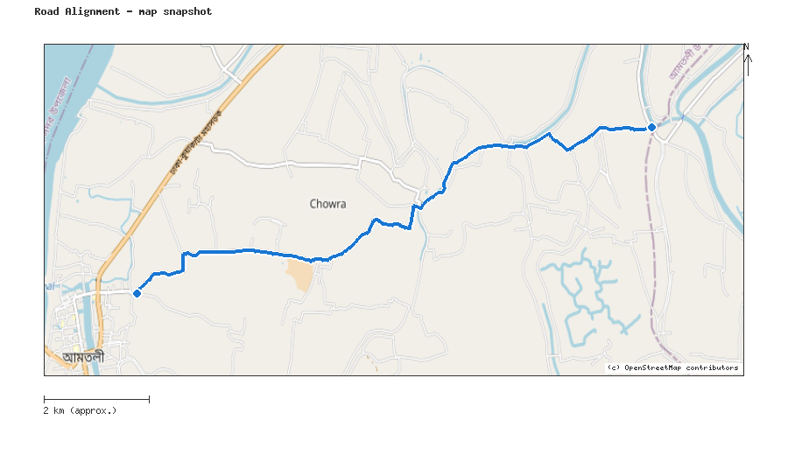
Map snapshot (OpenStreetMap) — for reference only. See the Road Evaluation page for the live interactive map.
Key Figures
AAR vs. baseline (1995–2014): Precip 45.5% · Temp 157.5%
RI_CC — Precip 3.90 · Temp 3.91 · Final 3.90
SSP scenario: SSP5-8.5 — Fossil-fuelled Development: a high-emissions pathway, roughly +4.4°C global mean warming by 2100 vs. pre-industrial levels.
Generated by RRAS — LGED Road Resilience Assessment System, developed by CReLIC. For internal DPP preparation use.

