Climate Resilience Brief Report
Generated 24 October 2026 · RRAS — LGED Road Resilience Assessment System
Amtali (AK High School) RHD- Gazipur GC Via Talukder Hat road.
504092001 · Amtali › BARGUNA › Barishal
12.35 km · Upazila Road · BC
MEDIUM RESILIENCE · Final RI_CC 3.52

SSP SSP5-8.5 · Design horizon to 2052
The Road & Its Climate Outlook
Amtali (AK High School) RHD- Gazipur GC Via Talukder Hat road. (504092001) is a Upazila Road road spanning 12.35 km through Upazila: Amtali, District: BARGUNA, Division: Barishal. Assessed under the SSP5-8.5 climate pathway, with a design horizon to 2052, its computed climate resilience index (RICC) is 3.52 — rated MEDIUM.
Hello, I'm delighted to be your climate and data assistant. I can provide detailed information and insights on a wide range of topics related to climate, data analysis, and environmental science.
My capabilities include:
1. Climate Data Analysis: I can help with analyzing and interpreting climate-related data, such as temperature trends, precipitation patterns, and extreme weather events.
2. Environmental Research: I can assist with researching and summarizing information on various environmental topics, including climate change, sustainability, and conservation.
3. Data Visualization: I can help create interactive and informative visualizations to communicate complex climate and data insights effectively.
4. Statistical Modeling: I can provide guidance on statistical modeling techniques, such as regression analysis, time series analysis, and machine learning algorithms, to extract insights from climate and environmental data.
5. Climate Change Mitigation and Adaptation: I can offer information and strategies on reducing greenhouse gas emissions, transitioning to renewable energy sources, and adapting to the impacts of climate change.
Some specific areas I can provide detailed answers on include:
• Climate Change: causes, effects, and mitigation strategies
• Renewable Energy: solar, wind, hydro, geothermal, and biomass energy
• Sustainable Development: sustainable agriculture, transportation, and urban planning
• Weather and Climate Extremes: heatwaves, droughts, floods, and storms
• Climate Policy and Governance: international agreements, national policies, and local initiatives
• Ecosystems and Biodiversity: conservation, restoration, and management of ecosystems
• Climate and Health: impacts of climate change on human health and well-being
• Climate and Economics: economic benefits and costs of climate change mitigation and adaptation
Please feel free to ask me any questions or request information on a specific topic, and I'll do my best to provide a detailed and informative response.

Recommended Adaptation Measures
• Climate Change: causes, effects, and mitigation strategies
• Renewable Energy: solar, wind, hydro, geothermal, and biomass energy
• Sustainable Development: sustainable agriculture, transportation, and urban planning
• Weather and Climate Extremes: heatwaves, droughts, floods, and storms
• Climate Policy and Governance: international agreements, national policies, and local initiatives
• Ecosystems and Biodiversity: conservation, restoration, and management of ecosystems
• Climate and Health: impacts of climate change on human health and well-being
• Climate and Economics: economic benefits and costs of climate change mitigation and adaptation

Road Alignment
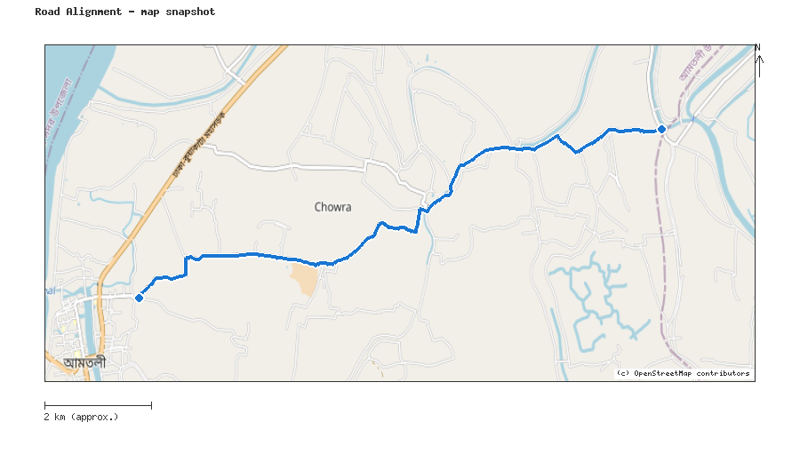
Map snapshot (OpenStreetMap) — for reference only. See the Road Evaluation page for the live interactive map.
Key Figures
AAR vs. baseline (1995–2014): Precip 45.5% · Temp 157.5%
RI_CC — Precip 3.52 · Temp 3.62 · Final 3.52
SSP scenario: SSP5-8.5 — Fossil-fuelled Development: a high-emissions pathway, roughly +4.4°C global mean warming by 2100 vs. pre-industrial levels.
Generated by RRAS — LGED Road Resilience Assessment System, developed by CReLIC. For internal DPP preparation use.

