Climate Resilience Brief Report
Generated 18 July 2026 · RRAS — LGED Road Resilience Assessment System
Amtali (AK High School) RHD- Gazipur GC Via Talukder Hat road.
504092001 · Amtali › BARGUNA › Barishal
12.35 km · Upazila Road · BC
MEDIUM RESILIENCE · Final RI_CC 3.74

SSP SSP5-8.5 · Design horizon to 2052
The Road & Its Climate Outlook
Amtali (AK High School) RHD- Gazipur GC Via Talukder Hat road. (504092001) is a Upazila Road road spanning 12.35 km through Upazila: Amtali, District: BARGUNA, Division: Barishal. Assessed under the SSP5-8.5 climate pathway, with a design horizon to 2052, its computed climate resilience index (RICC) is 3.74 — rated MEDIUM.
The resilience result of 3.74 indicates a medium resilience degree for the Amtali road, suggesting that it may face significant challenges due to climate change by 2046. Under the SSP5-8.5 scenario, the road will likely experience increased precipitation and temperature, with a 45.47% increase in precipitation and a 157.46% increase in temperature. This may lead to more frequent flooding and road damage. The design horizon year of 2046 and the road's 20-year surface design life require proactive adaptation measures.
• Upgrade
• Enhanced maintenance and retrofit
• Monitor and learn
• Improve drainage systems to mitigate monsoon flooding
• Implement embankment protection measures to prevent erosion
• Regularly inspect and maintain the road's BC surface to prevent damage from increased precipitation

Recommended Adaptation Measures
• Upgrade
• Enhanced maintenance and retrofit
• Monitor and learn
• Improve drainage systems to mitigate monsoon flooding
• Implement embankment protection measures to prevent erosion
• Regularly inspect and maintain the road's BC surface to prevent damage from increased precipitation

Road Alignment
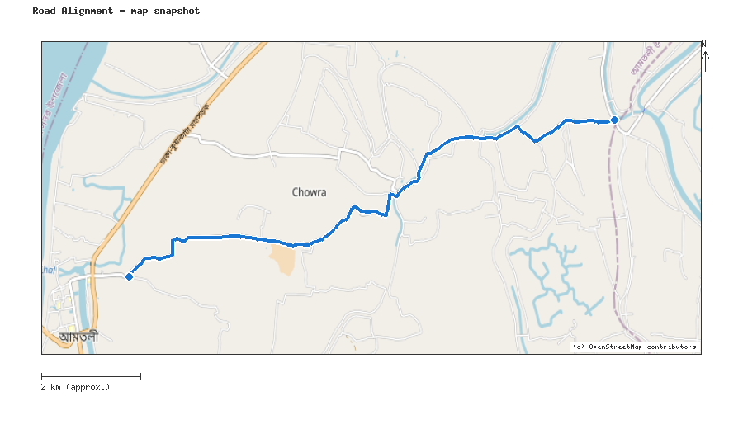
Map snapshot (OpenStreetMap) — for reference only. See the Road Evaluation page for the live interactive map.
Key Figures
AAR vs. baseline (1995–2014): Precip 45.5% · Temp 157.5%
RI_CC — Precip 3.74 · Temp 4.15 · Final 3.74
SSP scenario: SSP5-8.5 — Fossil-fuelled Development: a high-emissions pathway, roughly +4.4°C global mean warming by 2100 vs. pre-industrial levels.
Generated by RRAS — LGED Road Resilience Assessment System, developed by CReLIC. For internal DPP preparation use.

