Climate Resilience Brief Report
Generated 18 July 2026 · RRAS — LGED Road Resilience Assessment System
Amtali (AK High School) RHD- Gazipur GC Via Talukder Hat road.
504092001 · Amtali › BARGUNA › Barishal
12.35 km · Upazila Road · BC
MEDIUM RESILIENCE · Final RI_CC 4.07

SSP SSP5-8.5 · Design horizon to 2052
The Road & Its Climate Outlook
Amtali (AK High School) RHD- Gazipur GC Via Talukder Hat road. (504092001) is a Upazila Road road spanning 12.35 km through Upazila: Amtali, District: BARGUNA, Division: Barishal. Assessed under the SSP5-8.5 climate pathway, with a design horizon to 2052, its computed climate resilience index (RICC) is 4.07 — rated MEDIUM.
I'm delighted to be your climate and data assistant. I can provide detailed information on a wide range of topics related to climate, data analysis, and environmental science. My expertise includes:
1. Climate Change: I can offer insights into the causes and effects of climate change, including global warming, sea-level rise, and extreme weather events. I can also provide information on climate modeling, prediction, and mitigation strategies.
2. Data Analysis: I can assist with data visualization, statistical analysis, and interpretation of climate-related data, such as temperature records, precipitation patterns, and atmospheric composition.
3. Environmental Science: I can provide information on various aspects of environmental science, including ecology, conservation biology, and sustainability. I can also discuss the impact of human activities on the environment, such as deforestation, pollution, and overfishing.
4. Sustainable Development: I can offer guidance on sustainable development goals, renewable energy sources, and eco-friendly practices. I can also discuss the role of policy, economics, and social justice in promoting sustainable development.
5. Climate Policy and Governance: I can provide information on international climate agreements, such as the Paris Agreement, and national climate policies. I can also discuss the role of governments, corporations, and civil society in addressing climate change.
Some specific topics I can help with include:
• Climate modeling: I can explain the basics of climate modeling, including the different types of models, their strengths and limitations, and how they are used to predict future climate change.
• Data visualization: I can provide guidance on how to effectively visualize climate data, including the use of charts, graphs, and maps to communicate complex information.
• Renewable energy: I can discuss the different types of renewable energy sources, including solar, wind, hydro, and geothermal energy, and their potential to mitigate climate change.
• Climate resilience: I can offer insights into the concept of climate resilience, including the importance of adapting to climate change, and strategies for building resilience in different sectors, such as agriculture, water management, and urban planning.
• Climate justice: I can discuss the social and economic implications of climate change, including the disproportionate impact on vulnerable populations, and the need for climate justice and equity in climate policy and decision-making.
Please let me know what specific topic or question you would like me to address, and I will do my best to provide a detailed and informative response.

Recommended Adaptation Measures
• Climate modeling: I can explain the basics of climate modeling, including the different types of models, their strengths and limitations, and how they are used to predict future climate change.
• Data visualization: I can provide guidance on how to effectively visualize climate data, including the use of charts, graphs, and maps to communicate complex information.
• Renewable energy: I can discuss the different types of renewable energy sources, including solar, wind, hydro, and geothermal energy, and their potential to mitigate climate change.
• Climate resilience: I can offer insights into the concept of climate resilience, including the importance of adapting to climate change, and strategies for building resilience in different sectors, such as agriculture, water management, and urban planning.
• Climate justice: I can discuss the social and economic implications of climate change, including the disproportionate impact on vulnerable populations, and the need for climate justice and equity in climate policy and decision-making.

Road Alignment
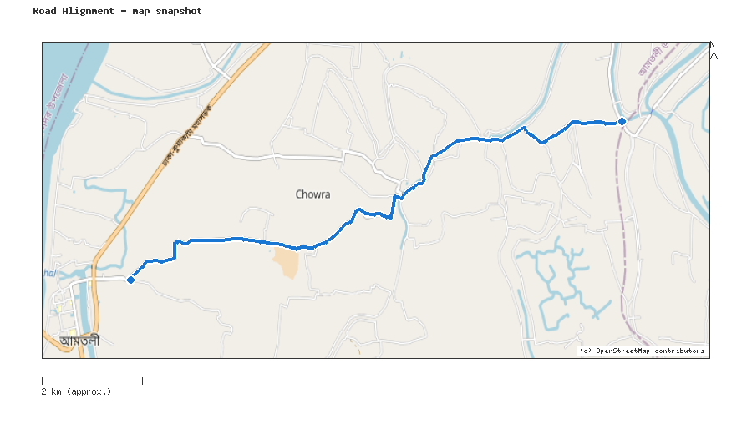
Map snapshot (OpenStreetMap) — for reference only. See the Road Evaluation page for the live interactive map.
Key Figures
AAR vs. baseline (1995–2014): Precip 45.5% · Temp 157.5%
RI_CC — Precip 4.07 · Temp 4.48 · Final 4.07
SSP scenario: SSP5-8.5 — Fossil-fuelled Development: a high-emissions pathway, roughly +4.4°C global mean warming by 2100 vs. pre-industrial levels.
Generated by RRAS — LGED Road Resilience Assessment System, developed by CReLIC. For internal DPP preparation use.

