Climate Resilience Brief Report
Generated 18 July 2026 · RRAS — LGED Road Resilience Assessment System
Paisharhat GC (RHD) to Shatla GC via Bagdha GC Road
506022003 · Agailjhara › BARISHAL › Barishal
5.93 km · Upazila Road · BC
MEDIUM RESILIENCE · Final RI_CC 3.49

SSP SSP5-8.5 · Design horizon to 2052
The Road & Its Climate Outlook
Paisharhat GC (RHD) to Shatla GC via Bagdha GC Road (506022003) is a Upazila Road road spanning 5.93 km through Upazila: Agailjhara, District: BARISHAL, Division: Barishal. Assessed under the SSP5-8.5 climate pathway, with a design horizon to 2052, its computed climate resilience index (RICC) is 3.49 — rated MEDIUM.
The computed resilience result of 3.49, indicating a medium resilience degree, suggests that the Paisharhat GC to Shatla GC via Bagdha GC Road will face significant climate-related challenges by 2046. Under the SSP5-8.5 scenario, the road is expected to experience a 45.47% increase in precipitation and a 157.46% rise in temperature, which may lead to more frequent and intense flooding and heat-related damage. This highlights the need for proactive adaptation measures to ensure the road's longevity and safety. The medium resilience degree implies that the road can withstand some climate-related stresses but will require enhancements to maintain its functionality.
• Upgrade
• Enhanced maintenance and retrofit
• Monitor and learn
• Improved drainage systems to handle increased precipitation
• Embankment protection to prevent erosion and landslides
• Regular maintenance checks to address heat-related damage

Recommended Adaptation Measures
• Upgrade
• Enhanced maintenance and retrofit
• Monitor and learn
• Improved drainage systems to handle increased precipitation
• Embankment protection to prevent erosion and landslides
• Regular maintenance checks to address heat-related damage

Road Alignment
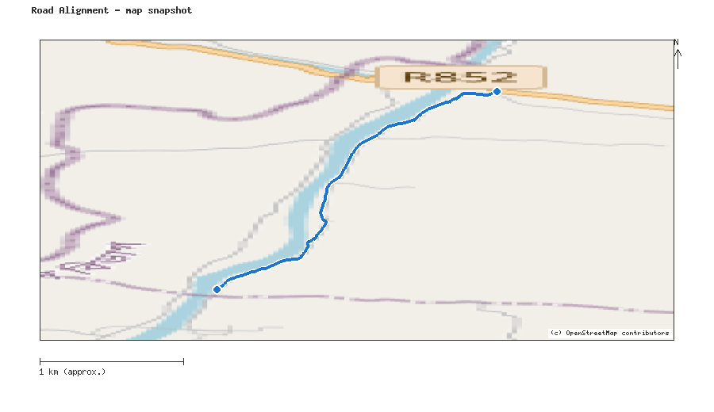
Map snapshot (OpenStreetMap) — for reference only. See the Road Evaluation page for the live interactive map.
Key Figures
AAR vs. baseline (1995–2014): Precip 45.5% · Temp 157.5%
RI_CC — Precip 3.49 · Temp 4.00 · Final 3.49
SSP scenario: SSP5-8.5 — Fossil-fuelled Development: a high-emissions pathway, roughly +4.4°C global mean warming by 2100 vs. pre-industrial levels.
Generated by RRAS — LGED Road Resilience Assessment System, developed by CReLIC. For internal DPP preparation use.

