Climate Resilience Brief Report
Generated 18 July 2026 · RRAS — LGED Road Resilience Assessment System
Nashratpur-Durgapur Via Kundogram
110062001 · Adamdighi › BOGURA › Rajshahi
10.17 km · Upazila Road · BC
MEDIUM RESILIENCE · Final RI_CC 5.00

SSP SSP5-8.5 · Design horizon to 2052
The Road & Its Climate Outlook
Nashratpur-Durgapur Via Kundogram (110062001) is a Upazila Road road spanning 10.17 km through Upazila: Adamdighi, District: BOGURA, Division: Rajshahi. Assessed under the SSP5-8.5 climate pathway, with a design horizon to 2052, its computed climate resilience index (RICC) is 5.00 — rated MEDIUM.
The Nashratpur-Durgapur Via Kundogram road, located in Adamdighi, Bogura, is expected to face significant climate-related challenges by its design horizon year of 2046. Under the SSP5-8.5 high-emissions pathway, the road will likely experience a 25.15% increase in precipitation and a 45.91% rise in temperature compared to the baseline period. Given its location in a non-coastal area, this road is particularly vulnerable to intensifying monsoon rainfall and flash flooding, as well as waterlogging on low-lying areas. The increased precipitation may lead to erosion and damage to the road's surface, while the rising temperatures may cause the bituminous surface to soften and accelerate rutting.
The computed resilience result of 5.00, indicating a medium resilience degree, suggests that the road requires proactive measures to enhance its resilience to climate-related hazards. The baseline engineering actions recommended for this degree of resilience include upgrade, enhanced maintenance and retrofit, and monitor and learn. To address the specific climate-related challenges faced by this road, additional adaptation measures should be considered.
• Upgrade
• Enhanced maintenance and retrofit
• Monitor and learn
• Drainage capacity upgrades to mitigate flash flooding and waterlogging
• Embankment protection to prevent erosion and channel migration
• Raised or flood-resilient pavement sections to reduce the impact of flooding
• Enhanced routine maintenance practices to address the increased maintenance burden due to climate change

Recommended Adaptation Measures
• Upgrade
• Enhanced maintenance and retrofit
• Monitor and learn
• Drainage capacity upgrades to mitigate flash flooding and waterlogging
• Embankment protection to prevent erosion and channel migration
• Raised or flood-resilient pavement sections to reduce the impact of flooding
• Enhanced routine maintenance practices to address the increased maintenance burden due to climate change

Road Alignment
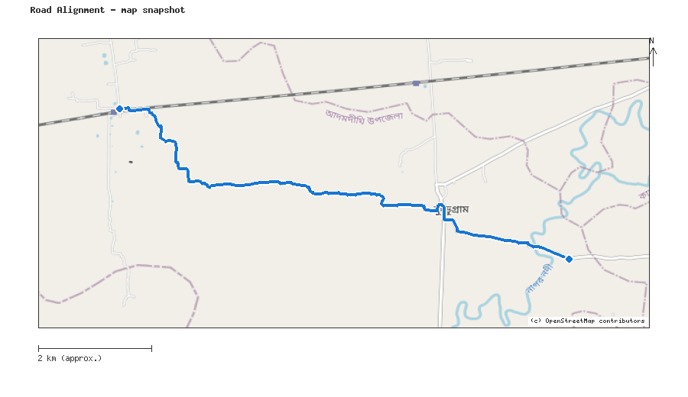
Map snapshot (OpenStreetMap) — for reference only. See the Road Evaluation page for the live interactive map.
Key Figures
AAR vs. baseline (1995–2014): Precip 25.2% · Temp 45.9%
RI_CC — Precip 6.79 · Temp 5.00 · Final 5.00
SSP scenario: SSP5-8.5 — Fossil-fuelled Development: a high-emissions pathway, roughly +4.4°C global mean warming by 2100 vs. pre-industrial levels.
Generated by RRAS — LGED Road Resilience Assessment System, developed by CReLIC. For internal DPP preparation use.

