Climate Resilience Brief Report
Generated 18 July 2026 · RRAS — LGED Road Resilience Assessment System
Jawa Bazar-Chhatak Road upto Andargaon
690232001 · Chhatak › SUNAMGANJ › Sylhet
13.16 km · Upazila Road · BC
MEDIUM RESILIENCE · Final RI_CC 5.00

SSP SSP5-8.5 · Design horizon to 2052
The Road & Its Climate Outlook
Jawa Bazar-Chhatak Road upto Andargaon (690232001) is a Upazila Road road spanning 13.16 km through Upazila: Chhatak, District: SUNAMGANJ, Division: Sylhet. Assessed under the SSP5-8.5 climate pathway, with a design horizon to 2052, its computed climate resilience index (RICC) is 5.00 — rated MEDIUM.
The Jawa Bazar-Chhatak Road upto Andargaon, located in Chhatak, SUNAMGANJ, Sylhet, has a medium resilience degree with a Final RI_CC of 5.00. Given the high-emissions pathway of SSP5-8.5, the road is expected to face significant climate-related challenges by its design horizon year of 2046. With a projected 27.67% increase in precipitation and 374.50% increase in temperature compared to the baseline period, the road is likely to experience intensifying monsoon rainfall and flash flooding, as well as rising dry-season temperatures that can soften bituminous surfaces and accelerate rutting.
The medium resilience degree indicates that the road requires upgrade, enhanced maintenance, and retrofit measures to withstand the projected climate changes. The road's location in a low-lying area makes it vulnerable to waterlogging, which can be exacerbated by the increased precipitation. To address these challenges, baseline engineering actions such as upgrade, enhanced maintenance and retrofit, and monitor and learn are necessary. Additionally, considering the road's surface type and location, extra adaptation measures can be taken to enhance its resilience.
• Upgrade
• Enhanced maintenance and retrofit
• Monitor and learn
• Drainage capacity upgrades to mitigate flash flooding and waterlogging
• Embankment protection to prevent erosion and channel migration
• Raised pavement sections in low-lying areas to reduce waterlogging
• Regular maintenance and inspection to address rutting and other damage caused by rising dry-season temperatures

Recommended Adaptation Measures
• Upgrade
• Enhanced maintenance and retrofit
• Monitor and learn
• Drainage capacity upgrades to mitigate flash flooding and waterlogging
• Embankment protection to prevent erosion and channel migration
• Raised pavement sections in low-lying areas to reduce waterlogging
• Regular maintenance and inspection to address rutting and other damage caused by rising dry-season temperatures

Road Alignment
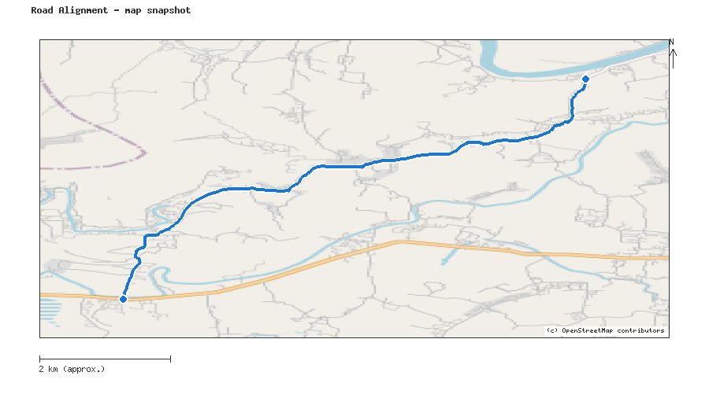
Map snapshot (OpenStreetMap) — for reference only. See the Road Evaluation page for the live interactive map.
Key Figures
AAR vs. baseline (1995–2014): Precip 27.7% · Temp 374.5%
RI_CC — Precip 6.87 · Temp 5.00 · Final 5.00
SSP scenario: SSP5-8.5 — Fossil-fuelled Development: a high-emissions pathway, roughly +4.4°C global mean warming by 2100 vs. pre-industrial levels.
Generated by RRAS — LGED Road Resilience Assessment System, developed by CReLIC. For internal DPP preparation use.

