Climate Resilience Brief Report
Generated 18 July 2026 · RRAS — LGED Road Resilience Assessment System
Polerhat GC-Jattrapur GC.
201082003 · Bagerhat Sadar › BAGERHAT › Khulna
12.34 km · Upazila Road · BC
MEDIUM RESILIENCE · Final RI_CC 4.91

SSP SSP5-8.5 · Design horizon to 2052
The Road & Its Climate Outlook
Polerhat GC-Jattrapur GC. (201082003) is a Upazila Road road spanning 12.34 km through Upazila: Bagerhat Sadar, District: BAGERHAT, Division: Khulna. Assessed under the SSP5-8.5 climate pathway, with a design horizon to 2052, its computed climate resilience index (RICC) is 4.91 — rated MEDIUM.
The Polerhat GC-Jattrapur GC road, located in Bagerhat Sadar, Bagerhat, is expected to face significant climate-related challenges by its design horizon year of 2052. Under the SSP5-8.5 scenario, with a projected 4.4°C global mean warming by 2100, this road will likely experience intensified monsoon rainfall and flash flooding, as well as rising dry-season temperatures. The computed resilience result of 4.91, indicating a medium resilience degree, suggests that the road's surface and structure may be compromised by these climate changes. The 46.85% increase in precipitation and 56.49% increase in temperature by the design horizon year will exacerbate waterlogging, erosion, and rutting on this BC surface road.
Given its location and surface type, this road is particularly vulnerable to waterlogging and erosion. The medium resilience degree implies that baseline engineering actions are necessary to maintain the road's functionality. By 2052, the road may experience more frequent and severe flooding, which could damage the road surface and underlying structure. To mitigate these risks, adaptation measures must be taken to enhance the road's resilience.
• Upgrade
• Enhanced maintenance and retrofit
• Monitor and learn
• Drainage capacity upgrades to mitigate waterlogging and flashed flooding
• Embankment protection measures to prevent erosion and channel migration
• Raised or flood-resilient pavement sections to protect the road from frequent flooding
• Cyclone-resistant materials and design considerations to protect the road from strong winds and storm surges

Recommended Adaptation Measures
• Upgrade
• Enhanced maintenance and retrofit
• Monitor and learn
• Drainage capacity upgrades to mitigate waterlogging and flashed flooding
• Embankment protection measures to prevent erosion and channel migration
• Raised or flood-resilient pavement sections to protect the road from frequent flooding
• Cyclone-resistant materials and design considerations to protect the road from strong winds and storm surges

Road Alignment
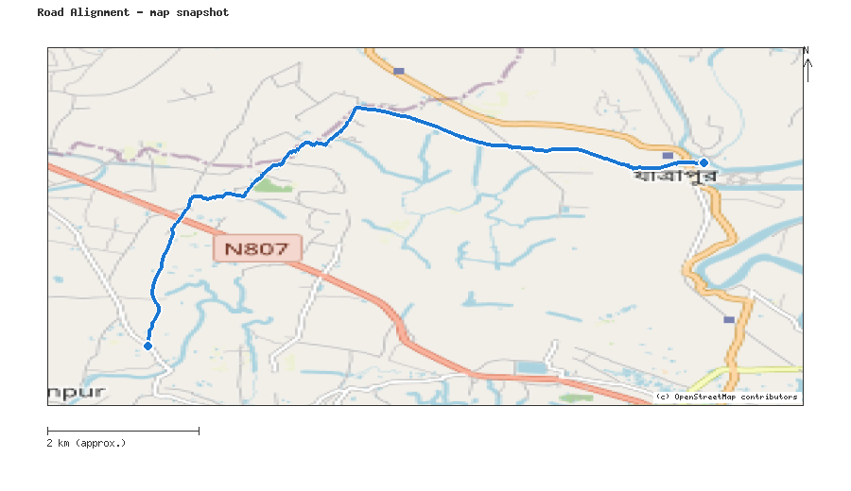
Map snapshot (OpenStreetMap) — for reference only. See the Road Evaluation page for the live interactive map.
Key Figures
AAR vs. baseline (1995–2014): Precip 46.9% · Temp 56.5%
RI_CC — Precip 4.91 · Temp 5.00 · Final 4.91
SSP scenario: SSP5-8.5 — Fossil-fuelled Development: a high-emissions pathway, roughly +4.4°C global mean warming by 2100 vs. pre-industrial levels.
Generated by RRAS — LGED Road Resilience Assessment System, developed by CReLIC. For internal DPP preparation use.

