Climate Resilience Brief Report
Generated 18 July 2026 · RRAS — LGED Road Resilience Assessment System
Bhurungamari Hospital - Telai High School via Thana ghat bazar Road.
149062002 · Bhurungamari › KURIGRAM › Rangpur
11.37 km · Upazila Road · BC
HIGH RESILIENCE · Final RI_CC 6.41

SSP SSP5-8.5 · Design horizon to 2052
The Road & Its Climate Outlook
Bhurungamari Hospital - Telai High School via Thana ghat bazar Road. (149062002) is a Upazila Road road spanning 11.37 km through Upazila: Bhurungamari, District: KURIGRAM, Division: Rangpur. Assessed under the SSP5-8.5 climate pathway, with a design horizon to 2052, its computed climate resilience index (RICC) is 6.41 — rated HIGH.
The Bhurungamari Hospital - Telai High School via Thana ghat bazar Road, located in Kurigram, Rangpur, has a computed resilience result of 6.41, indicating a high resilience degree. Given the SSP5-8.5 climate scenario, which predicts a global mean warming of approximately 4.4°C by 2100, this road is expected to face intensifying monsoon rainfall and flash flooding, as well as riverbank erosion and channel migration. By the design horizon year of 2052, the road will likely experience an 11.51% increase in precipitation and a 23.49% rise in temperature compared to the baseline period.
The high resilience degree suggests that the road can withstand the anticipated climate changes to some extent, but ongoing monitoring and learning are necessary to ensure its longevity. The road's location in a non-coastal area means that it is not exposed to tropical cyclones, storm surges, or salinity intrusion. However, the rising dry-season temperatures may still affect the bituminous surface, accelerating rutting and increasing maintenance needs. The road's surface type, BC, and category, Upazila Road, also play a role in its resilience, as they influence its drainage capacity and susceptibility to erosion.
• Monitor and learn
• Implement drainage capacity upgrades to mitigate the impacts of increased precipitation and flash flooding
• Construct embankment and slope protection measures to prevent erosion and channel migration
• Incorporate erosion control measures, such as geotextiles or riprap, to stabilize the road's surface and surrounding areas

Recommended Adaptation Measures
• Monitor and learn
• Implement drainage capacity upgrades to mitigate the impacts of increased precipitation and flash flooding
• Construct embankment and slope protection measures to prevent erosion and channel migration
• Incorporate erosion control measures, such as geotextiles or riprap, to stabilize the road's surface and surrounding areas

Road Alignment
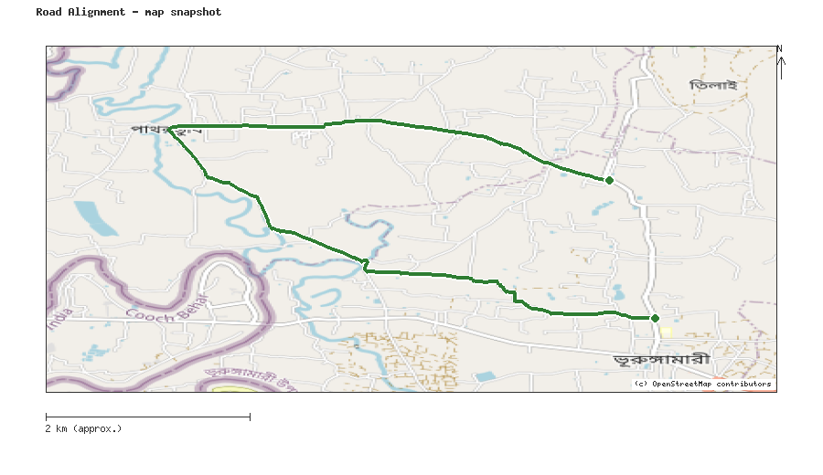
Map snapshot (OpenStreetMap) — for reference only. See the Road Evaluation page for the live interactive map.
Key Figures
AAR vs. baseline (1995–2014): Precip 11.5% · Temp 23.5%
RI_CC — Precip 9.52 · Temp 6.41 · Final 6.41
SSP scenario: SSP5-8.5 — Fossil-fuelled Development: a high-emissions pathway, roughly +4.4°C global mean warming by 2100 vs. pre-industrial levels.
Generated by RRAS — LGED Road Resilience Assessment System, developed by CReLIC. For internal DPP preparation use.

