Climate Resilience Brief Report
Generated 18 July 2026 · RRAS — LGED Road Resilience Assessment System
Ilisha R H D (Parangonj Bazer)-Pagashia Bagar hat Rd.
509182003 · Bhola Sadar › BHOLA › Barishal
6.50 km · Upazila Road · BC
MEDIUM RESILIENCE · Final RI_CC 3.80

SSP SSP3-7.0 · Design horizon to 2052
The Road & Its Climate Outlook
Ilisha R H D (Parangonj Bazer)-Pagashia Bagar hat Rd. (509182003) is a Upazila Road road spanning 6.50 km through Upazila: Bhola Sadar, District: BHOLA, Division: Barishal. Assessed under the SSP3-7.0 climate pathway, with a design horizon to 2052, its computed climate resilience index (RICC) is 3.80 — rated MEDIUM.
No AI-generated narrative yet for this assessment. Generate one from the "Ask AI" button on the Road Evaluation page, then re-download this report to include it.
Recommended Adaptation Measures
• Upgrade
• Enhanced maintenance and retrofit
• Monitor and learn

Road Alignment
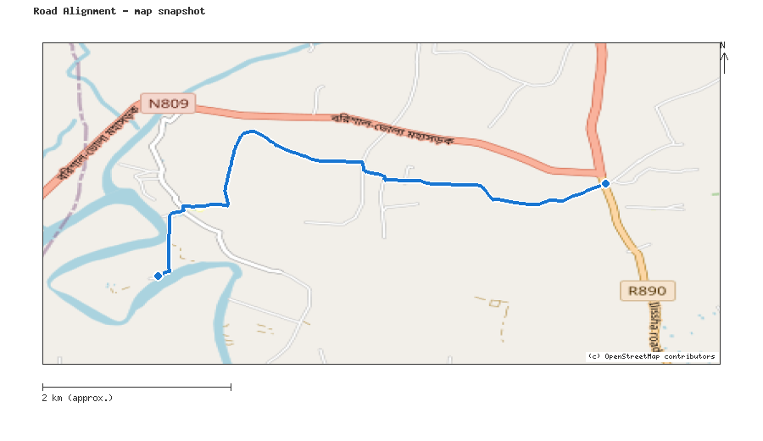
Map snapshot (OpenStreetMap) — for reference only. See the Road Evaluation page for the live interactive map.
Key Figures
AAR vs. baseline (1995–2014): Precip 3.8% · Temp 21.2%
RI_CC — Precip 3.90 · Temp 3.80 · Final 3.80
SSP scenario: SSP3-7.0 — Regional Rivalry: a medium-to-high emissions pathway, roughly +3.6°C global mean warming by 2100 vs. pre-industrial levels.
Generated by RRAS — LGED Road Resilience Assessment System, developed by CReLIC. For internal DPP preparation use.

