Climate Resilience Brief Report
Generated 24 October 2026 · RRAS — LGED Road Resilience Assessment System
Bhurungamari Hospital - Telai High School via Thana ghat bazar Road.
149062002 · Bhurungamari › KURIGRAM › Rangpur
11.37 km · Upazila Road · BC
HIGH RESILIENCE · Final RI_CC 7.00

SSP SSP5-8.5 · Design horizon to 2052
The Road & Its Climate Outlook
Bhurungamari Hospital - Telai High School via Thana ghat bazar Road. (149062002) is a Upazila Road road spanning 11.37 km through Upazila: Bhurungamari, District: KURIGRAM, Division: Rangpur. Assessed under the SSP5-8.5 climate pathway, with a design horizon to 2052, its computed climate resilience index (RICC) is 7.00 — rated HIGH.
No AI-generated narrative yet for this assessment. Generate one from the "Ask AI" button on the Road Evaluation page, then re-download this report to include it.
Recommended Adaptation Measures
• Monitor and learn

Road Alignment
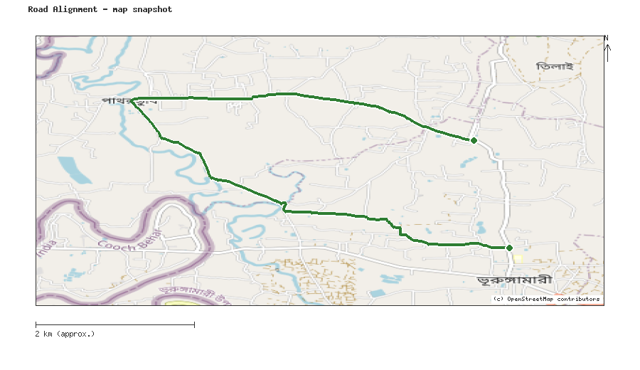
Map snapshot (OpenStreetMap) — for reference only. See the Road Evaluation page for the live interactive map.
Key Figures
AAR vs. baseline (1995–2014): Precip 11.5% · Temp 23.5%
RI_CC — Precip 9.90 · Temp 7.00 · Final 7.00
SSP scenario: SSP5-8.5 — Fossil-fuelled Development: a high-emissions pathway, roughly +4.4°C global mean warming by 2100 vs. pre-industrial levels.
Generated by RRAS — LGED Road Resilience Assessment System, developed by CReLIC. For internal DPP preparation use.

